***On my honor, I pledge that I have not violated the provisions of the NJIT Student Honor Code***

STUDENT TEAM No__**2**__

Name Signature

…Arsh Bhamla………… ___**ARSH BHAMLA~~___~~**_ …Pranay KC………….. _**_PRANAY RAJ KC_____** ..Shreedhar Rajendran. **__Shreedhar Rajendran—**

..Christopher Karkenny. __**Christopher Karkenny**_

Experiment performed on date _03/28/2025__

Report submitted on date ___04/04/2025______

Returned for corrections on date _________ Grade ______

Returned after corrections on date _________ Grade ______

**Introduction**

In this lab, we will learn more about the superposition principle and how each source contributes on its own and simplifies the process of understanding complicated circuits. We will be applying this principle to both DC and AC circuits and will start by building the circuit and measuring the load voltage in different scenarios to validate the superposition principle under varying conditions through calculated and measured values and extending the principle’s applicability to alternating current scenarios using an oscilloscope. This lab also involves creating the Thevenin equivalent circuit for the given configuration, enabling the further understanding of circuit characteristics. Through this hands-on experience, we will gain a better understanding of the theoretical principles.

**Procedure**

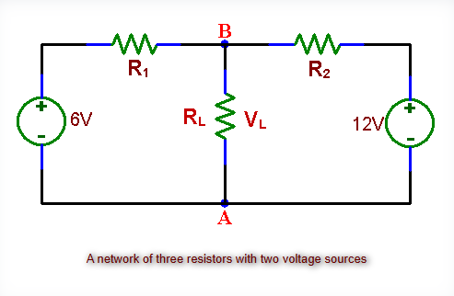

Figure taken from [ECE 294 manual](https://ecelabs.njit.edu/ece294/lab7.php)

**3.1 The Superposition Principle**

We will first assemble the circuit as shown in fig.3 consisting of a 6V and 12V battery, negatives at node A, positives connected in series with resistors R1 and R2. We will leave RL disconnected initially and measure VL (A to B) with RL infinite and compare it to VL = (6V*R2 + 12V*R1)/R1 + R2. We will then use the superposition principle to measure VB1 (12V shorted), then VB2 (6V shorted), sum VL = VB1 + VB2, and compare the result. We will then add RL and calculate VL = (6V/R1 + 12V/R2) / (1/R1 + 1/R2 + 1/RL). We will then replace 6V DC with peak AC, use an oscilloscope to confirm superposition by comparing total VL(t) to the sum AC-only and DC-only waveforms.

**3.2 The Thevenin Equivalent Circuit**

We will design the Thevenin equivalent circuit of fig. 3 without RL and calculate VTH as the open circuit voltage across A and B and RTH as R1||R2 with batteries shorted. We will use a resistance substitution box to set RTH and verify it with an ohmmeter and assemble the circuit with a VTH source in series with RTH. For the next part, we will verify by measuring VL across A and B first with RL = infinity by having an open circuit and VL=VTH and compare the equivalence.

**3.3 Circuit Simulation**

To create the circuit in multisim, we will open a new schematic and place two DC voltage sources 6V and 12V in parallel with their positive terminals wired together at the top and negative terminals at the bottom and add small series resistors to each source to avoid parallel voltage source errors and then connect resistors R1 and R2 in series along the top path between the 6V and the 12V source with a node labeled B between them. We will place a load resistor between node B and a bottom node labeled A connected to the negative terminals and add a voltmeter across RL to measure VL and ensure all connections form a closed loop.

**Data and Calculations**

**3.1 The Superposition Principle**

**Part A:**

**6V Reading:**

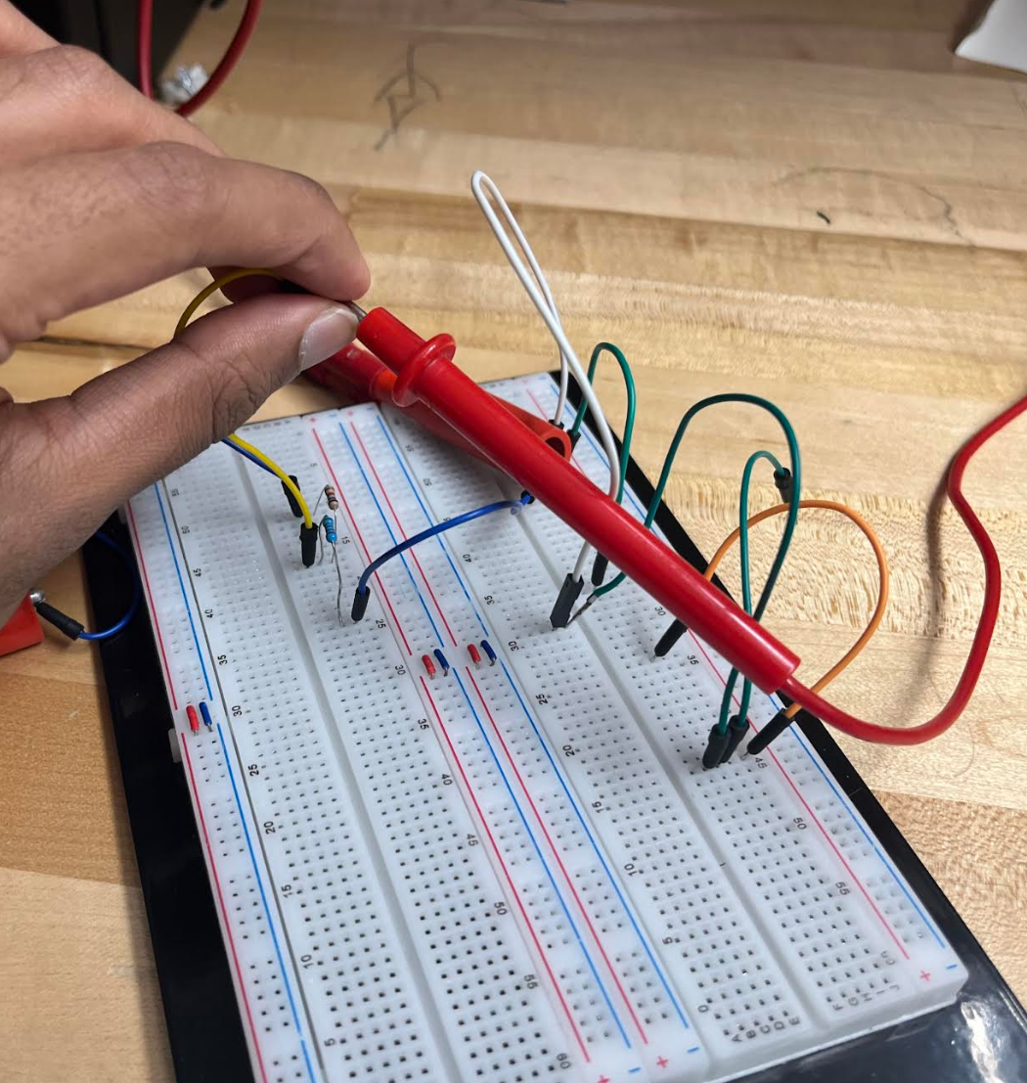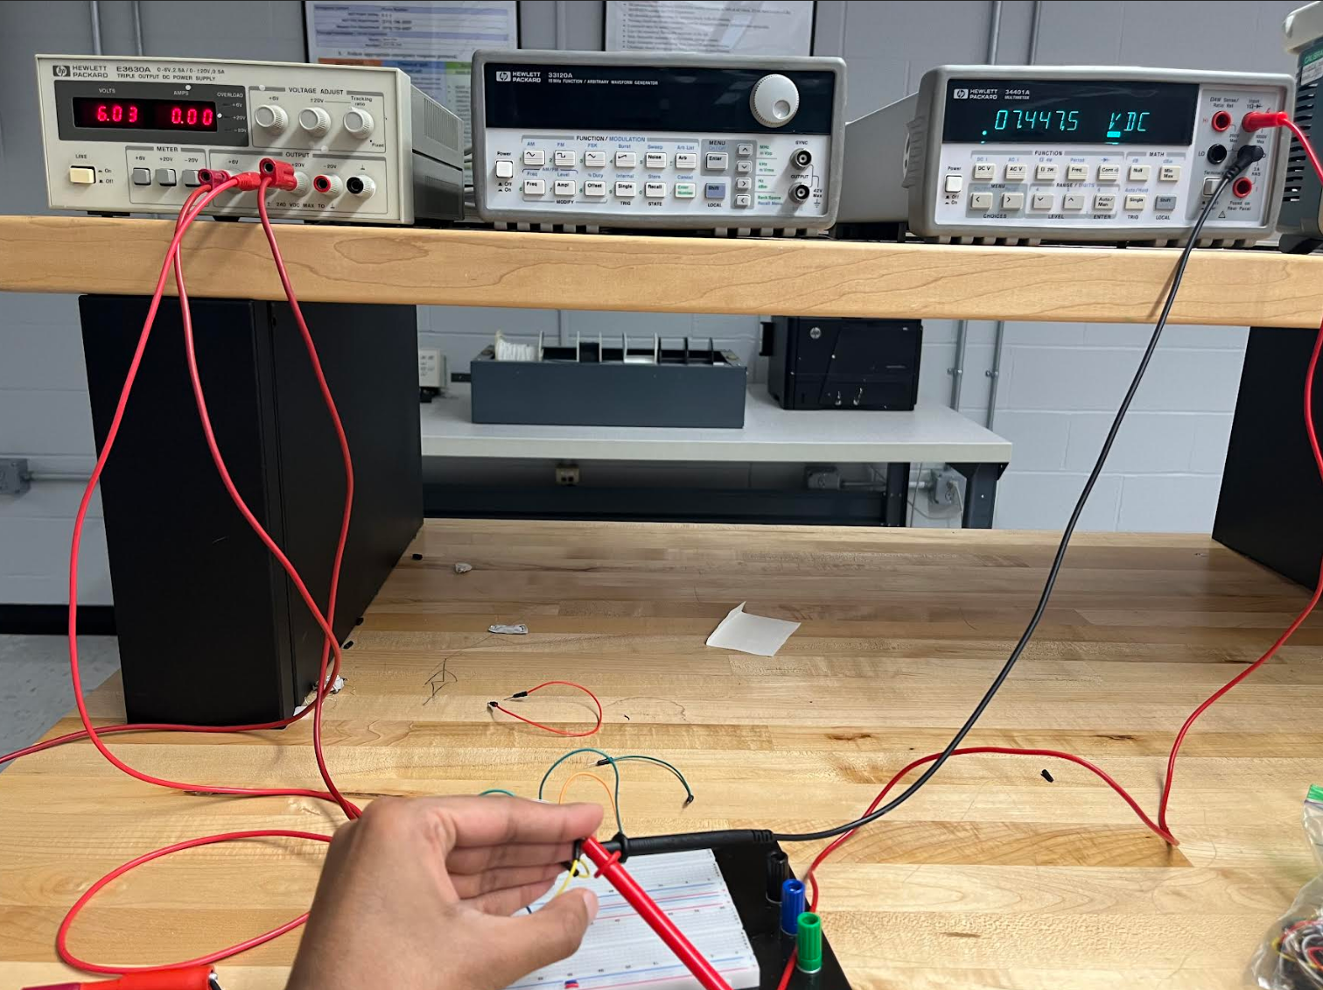

**12V Reading:**

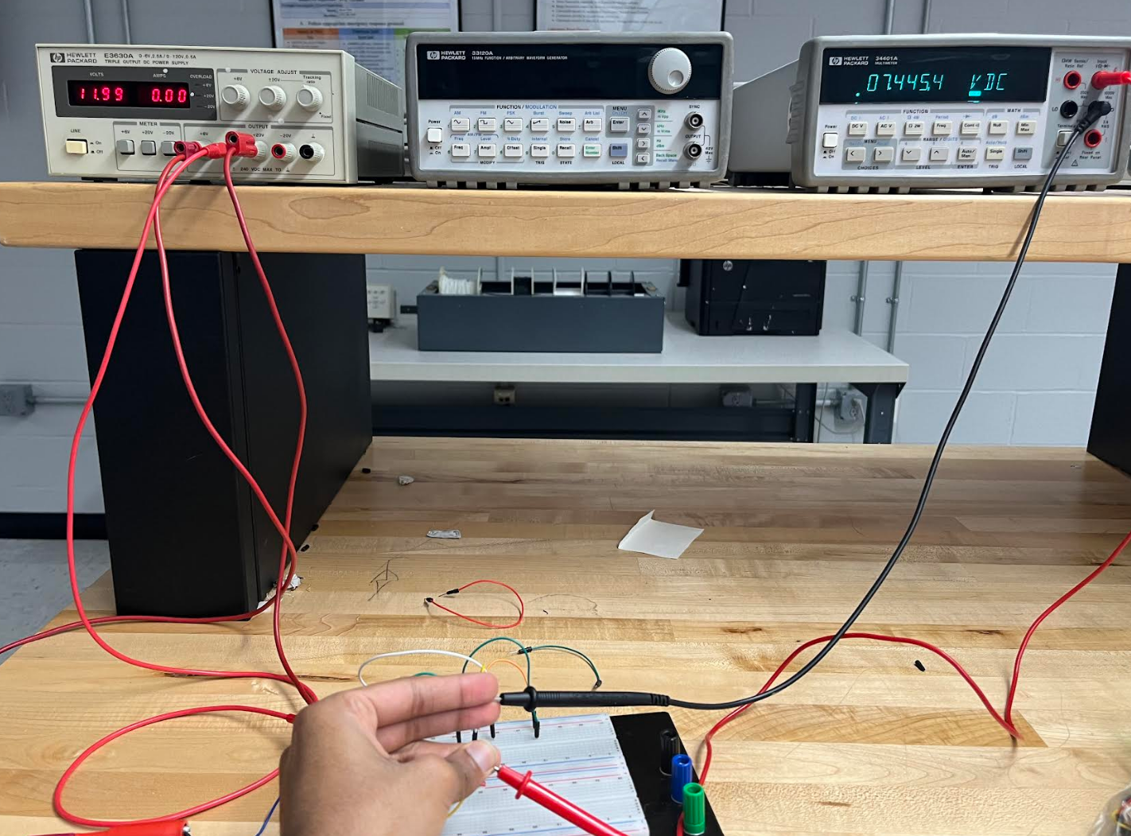

This matches the calculated value.

**Part B:**

The superposition gets us the same voltage at that point node of measurement at point B. Here is the proof:

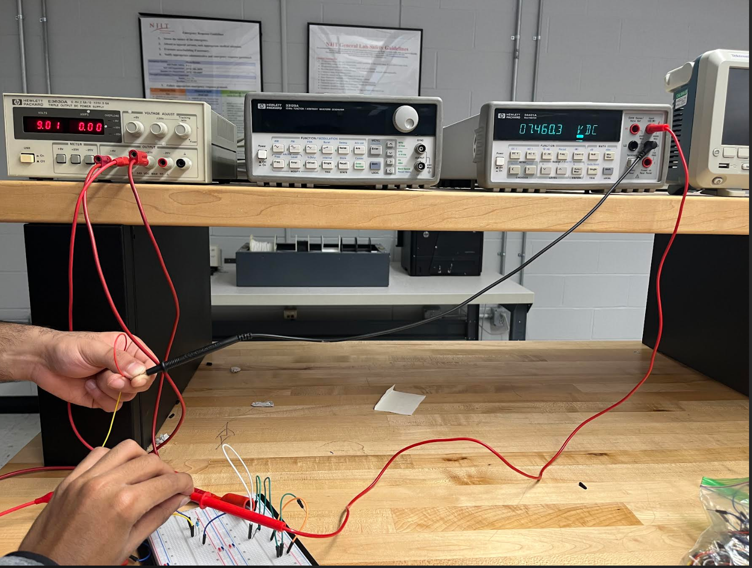

**Part C:**

**Circuit Diagram:**

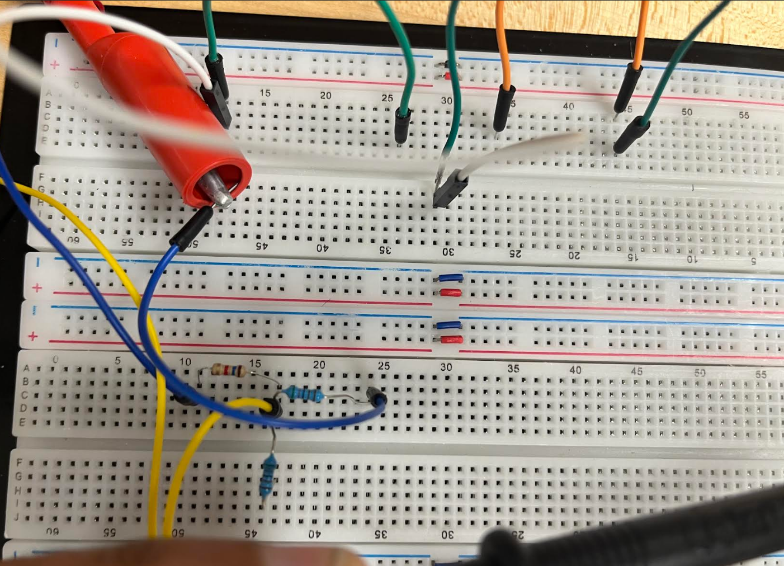.

**Readings:**

**12V Source:**

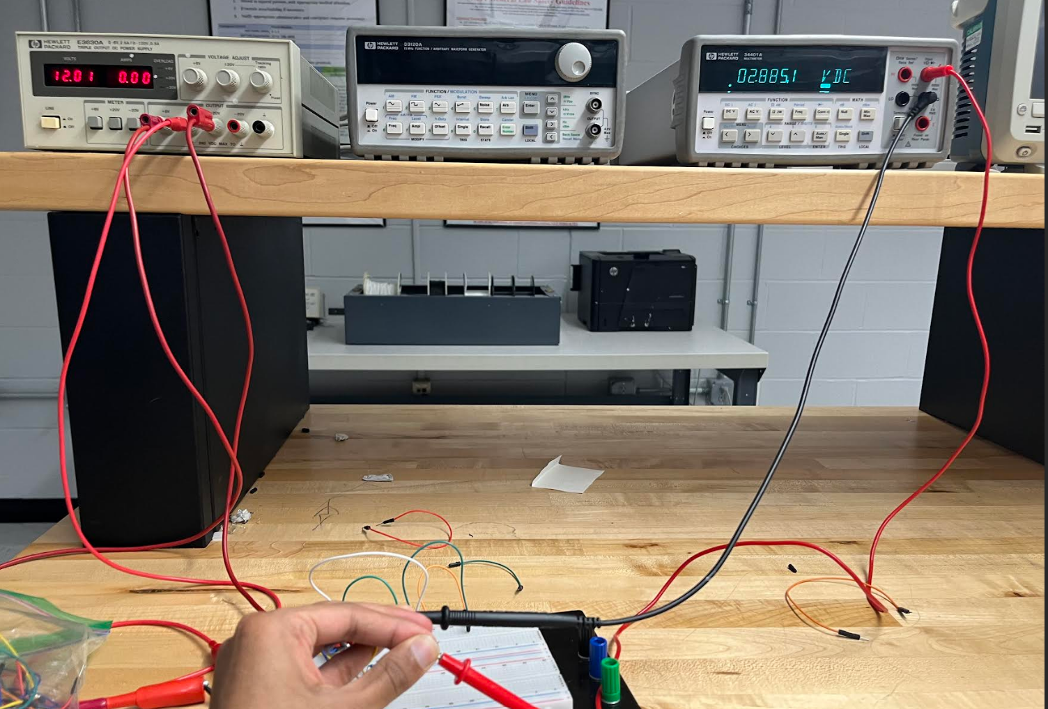

**6V Source:**

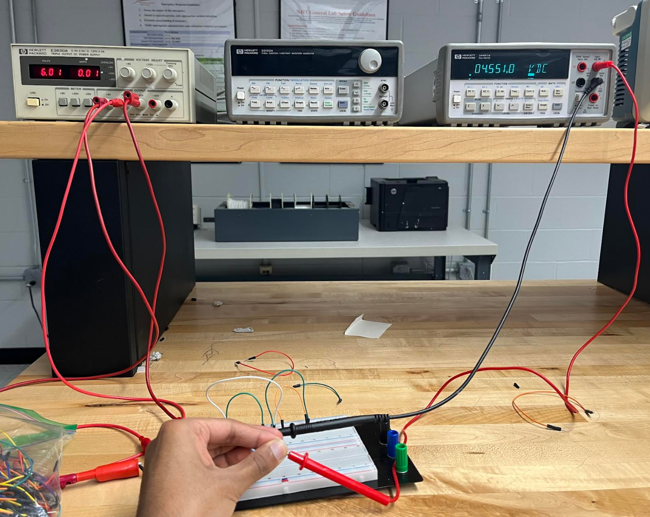

**Part D:**

**6V Source:**

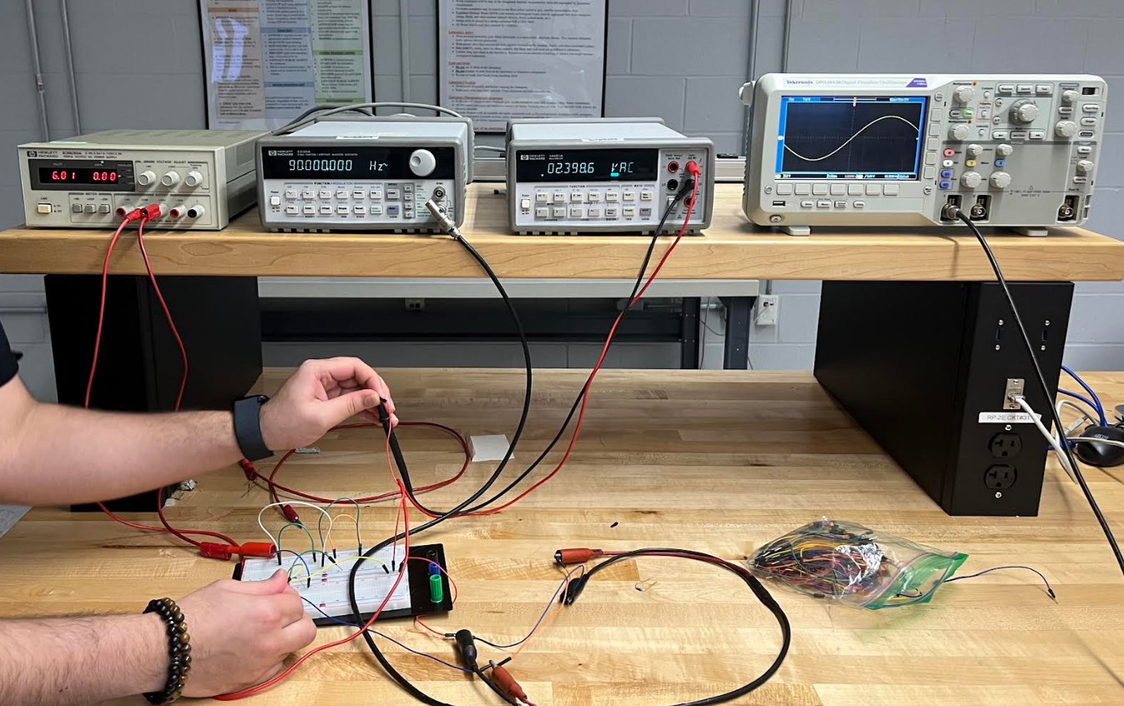

Giving us Vrms = 2.398V, Vmax = 3.39V, and Vp-p = 6.78V, it approximately equals the superposition with a slight margin of error.

**3.2 The Thevenin Equivalent Circuit**

**Part A:**

**Thevenin Circuit:**

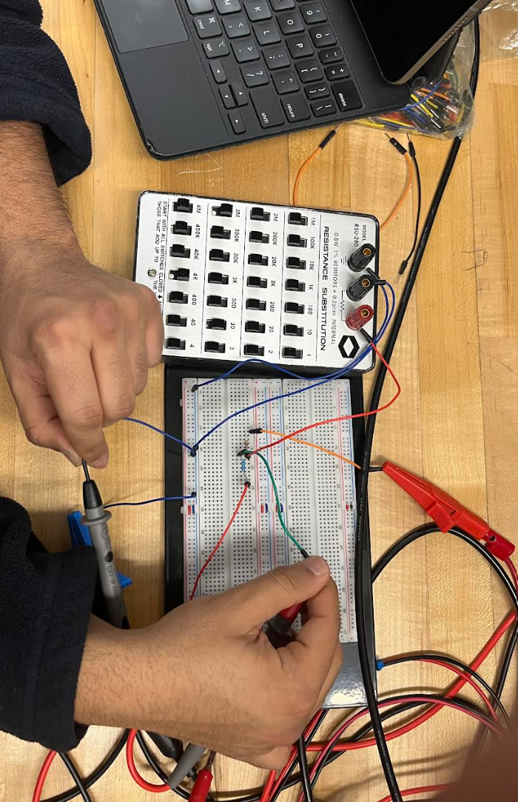

**Readings:**

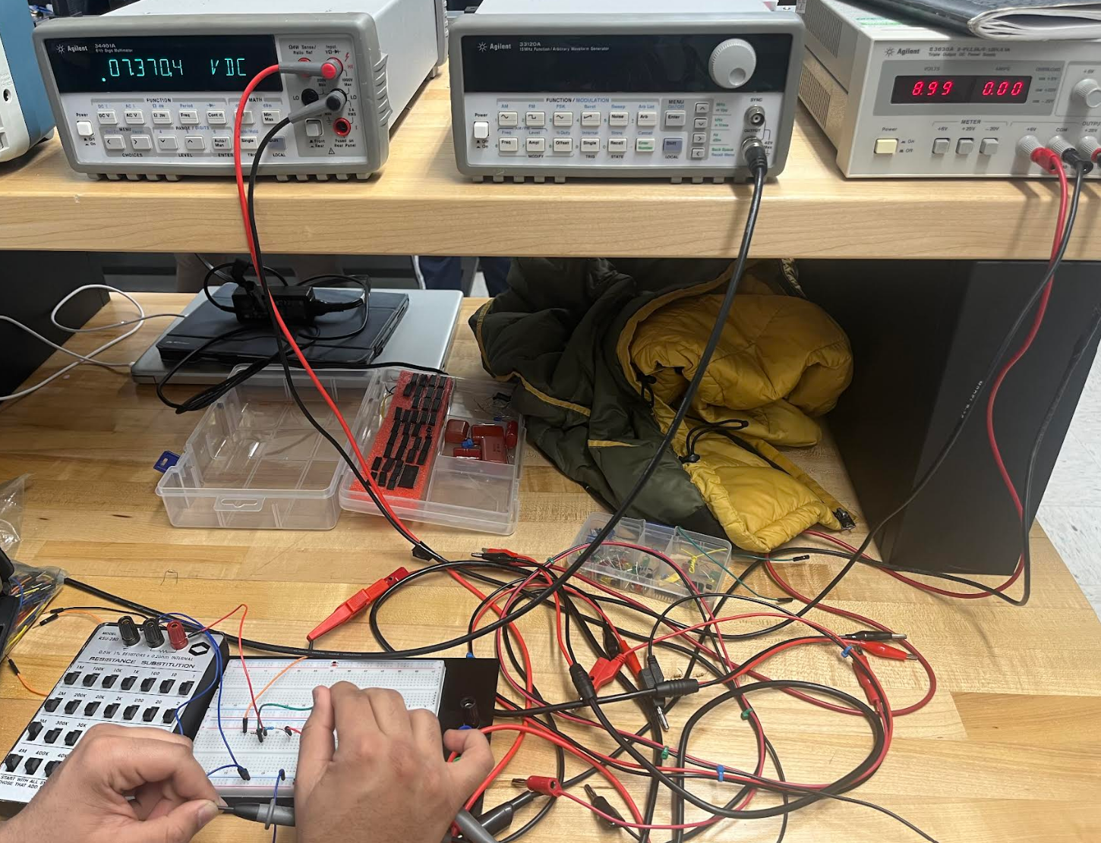

**Part B:**

According to our experimental results, the thevenin circuit gives an approximately same voltage at point B as the circuit without the R_l did in 3.1 Part A, with an approximate voltage of 7.37V and a slight margin of error of 1.47%.

**Thevenin Circuit:**

*Calculated (and approximate):*

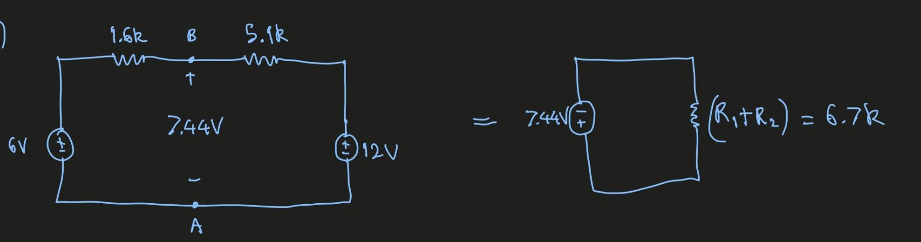

**3.3 Circuit Simulation**

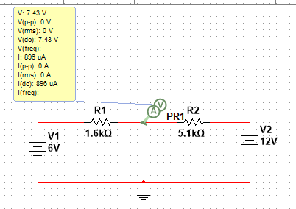

The following circuit on multisim is the same as the one given in 3.2, Part B’s calculated thevenin circuit. The probe (Point B) takes the voltage with respect to ground (Point A).

The difference between these two values gives an error of 0.134%.

**Discussion**

Our main goal was to gain the practical application of the superposition principle and Thevenin’s theorem in analyzing a linear circuit with multiple sources. In part 3.1 the principle was tested by measuring the voltage VL across points A and B and comparing it to the sum of voltages produced by each source acting alone. Under both open-circuit conditions with RL being infinity, the measured VL was aligned with the value calculated using superposition. The applicability to AC signals was also confirmed by replacing the DC source with an AC source and observing the resulting waveforms on an oscilloscope. For part 3.2, the Thevenin’s theorem was applied with VTH and RTH determined from the original circuit’s open-circuit voltage and equivalent resistance. The assembled Thevenin circuit accurately mirrored the original circuit’s behavior highlighting Thevenin’s theorem as a valuable method for simplifying complex circuit analysis while preserving accuracy from the load’s perspective.

**Conclusions**

This lab showed how important and useful the two major concepts of superposition principle and Thevenin’s theorem are in linear circuit analysis. For 3.1 we proved that the superposition principle works by demonstrating that the voltage across a load is equal to the sum of the voltages from each source individually. Any slight differences were due to the component tolerances and the results held true for both DC and AC signals. For part 3.2, we used Thevenin’s theorem to simplify a complex circuit into an equivalent model which accurately predicted how the circuit would behave under different load conditions. These experiments highlighted how practical these theorems are and allowed us to better understand how these concepts make circuit analysis more accurate and efficient.